- Ans>
1. Deterministic Models:
These models produce consistent and predictable results given the same initial conditions. They do not account for randomness.
- Example: Calculating the trajectory of a ball based on its initial speed and angle.
2. Stochastic Models:
These models incorporate random variables and account for uncertainty or variability in the system.
- Example: Weather forecasting models that include probabilities of different outcomes.
3. Static Models:
Static models focus on a system at a single point in time, without considering changes over time.
- Example: Analyzing the current traffic flow in a city.
4. Dynamic Models:
Dynamic models represent systems that evolve over time and show changes in the state of the system.
- Example: Studying how a disease spreads over weeks or months.
5. Continuous Models:
Continuous models describe systems using equations that change smoothly over time, often represented by differential equations.
- Example: Modeling how the temperature of an object changes continuously.
6. Discrete Models:
Discrete models analyze systems in steps or intervals, using specific, separate points in time.
- Example: Tracking the daily population of animals in a wildlife reserve.
- Ans
A system consists of interconnected components that work together to achieve a specific goal. These components can be classified based on their function within the system.
1. Input:
Inputs are the resources, energy, or information that enter a system to initiate or sustain its operation.
- Example: In a manufacturing system, raw materials are the inputs.
2. Output:
Outputs are the products, results, or services generated by the system.
- Example: In a power plant, electricity is the output.
3. Processes:
Processes are the actions or mechanisms within the system that transform inputs into outputs.
- Example: In a computer, the processor executes instructions to generate results.
4. Feedback:
Feedback provides information about the system's performance, allowing adjustments to maintain or improve function.
- Example: A thermostat uses feedback to adjust room temperature.
5. Boundary:
The boundary defines the limits of the system and separates it from its external environment.
- Example: The fence around a garden represents its boundary.
6. Environment:
The environment includes all external factors that interact with the system but are not part of it.
- Example: A factory's environment may include nearby weather conditions and government regulations.
- Ans
Differential and partial differential equations (PDEs) are mathematical tools used to model dynamic systems where change occurs over time or space. Their significance in simulations lies in the following:
1. Representation of Change:
- Differential equations describe how quantities change over time (ordinary differential equations) or over both time and space (partial differential equations).
- Example: Newton's laws of motion use differential equations to describe how objects move under force.
2. Realistic Modeling:
- PDEs can represent complex physical processes, such as heat transfer, fluid dynamics, and wave propagation.
- Example: The heat equation (a PDE) models how heat spreads in a material.
3. Predictive Power:
- They allow simulations to forecast system behavior under different conditions.
- Example: Weather models use PDEs to predict temperature, pressure, and wind patterns.
4. Universality:
- Differential equations are used across various fields like engineering, physics, biology, and finance to simulate real-world phenomena.
- Example: Population growth in biology is often modeled using logistic differential equations.
5. Basis for Numerical Simulations:
- Many computational simulation methods (e.g., finite element analysis, finite difference methods) rely on solving PDEs to approximate system behavior.
- Example: Structural simulations in engineering to test bridge designs.
- Ans
Static Physical Model vs. Dynamic Physical Model
Static Physical Model | Dynamic Physical Model
Represents a system at rest, with no changes over time. | Represents a system that changes or evolves over time.
No moving parts or motion. | Includes motion or interactions to show dynamic behavior.
Used for structural or design analysis. | Used for performance, behavior, or process analysis.
Example: A 3D printed model of a car. | Example: A moving car on a test track.
Dynamic Physical Model
A dynamic physical model is used to replicate and analyze the behavior of a real system over time.
Characteristics:
- Includes motion, change, or interaction.
- Simulates real-world conditions.
- Requires external inputs like forces, fluids, or electrical signals.
Example:
A wind tunnel model is a classic example of a dynamic physical model.
- Purpose: To analyze aerodynamic performance.
- Setup: A scaled model of an airplane is tested under controlled airflow conditions in a wind tunnel.
- Benefits: Allows engineers to study lift, drag, and stability, leading to design improvements before building a full-scale airplane.
5 ans
The simulation model building can be broken into 4 phases:
I Phase
o Consists of steps 1 and 2
o It is period of discovery/orientation
o The analyst may have to restart the process if it is not fine-tuned
o Recalibrations and clarifications may occur in this phase or another phase.
II Phase
o Consists of steps 3,4,5,6 and 7
o A continuing interplay is required among the steps
o Exclusion of model user results in implications during implementation
III Phase
o Consists of steps 8,9 and 10
o Conceives a thorough plan for experimenting
o Discrete-event stochastic is a statistical experiment
o The output variables are estimates that contain random error and therefore proper
statistical analysis is required.
IV Phase
o Consists of steps 11 and 12
o Successful implementation depends on the involvement of user and every steps
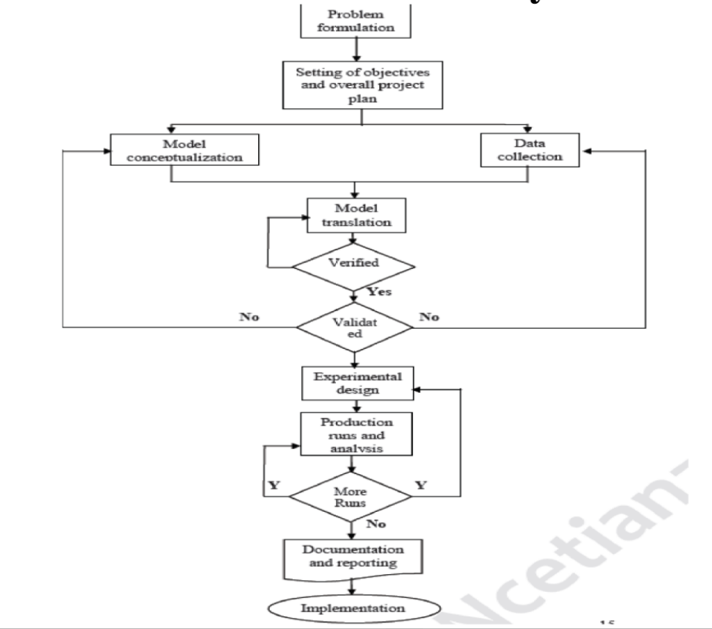

6 ans
Numerical Methods vs. Analytical Methods in System Simulation
Aspect | Numerical Methods | Analytical Methods
Definition | Approximate solutions using computational algorithms. | Exact solutions using mathematical formulas.
Approach | Iterative calculations; step-by-step approximations. | Direct algebraic or closed-form solutions.
Complexity | Handles complex systems that may lack closed-form solutions. | Suitable for simpler systems with known solutions.
Accuracy | Results are approximate, depending on step size and precision. | Provides exact results if assumptions are met.
Tools Used | Requires computational tools (e.g., MATLAB, Python). | Solved manually or symbolically using equations.
Examples | Finite element methods, Monte Carlo simulations. | Solving linear equations, calculating integrals.
Application | Used when analytical methods are not feasible. | Used for straightforward systems with solvable equations.

7 ans
A distributed lag model is a statistical tool used to analyze the effect of an independent variable on a dependent variable over several time periods. Instead of assuming the effect happens immediately, the model accounts for delayed or lagged effects spread over time.
Key Characteristics:
- Lagged Effects: The influence of the independent variable is spread across multiple time periods.
- Decay of Impact: The strength of the effect may decrease (decay) over time.
- Applications: Commonly used in economics, finance, and social sciences to study time-dependent relationships.
Example:
A company invests in a marketing campaign, and the effect on sales is analyzed over several months.
- Independent Variable (X): Advertising expenditure.
- Dependent Variable (Y): Monthly sales.
- The model might look like this: Yt=β0+β1Xt+β2Xt−1+β3Xt−2+⋯+ϵtY_t = \beta_0 + \beta_1 X_t + \beta_2 X_{t-1} + \beta_3 X_{t-2} + \dots + \epsilon_tYt​=β0​+β1​Xt​+β2​Xt−1​+β3​Xt−2​+⋯+ϵt​
- Here, XtX_tXt​ is the spending in the current month, Xt−1X_{t-1}Xt−1​ is the spending last month, and so on. The coefficients (β1,β2,…\beta_1, \beta_2, \dotsβ1​,β2​,…) measure the effect of spending over time.
Practical Insight:
The model shows that advertising not only impacts current sales but also has a lingering effect in subsequent months.
Applications:
- Economics: Analyzing the impact of government policies over time.
- Finance: Studying how changes in interest rates affect the economy in the future.
- Marketing: Evaluating the long-term effects of promotional campaigns.

8 ans
A model is a simplified representation of a real-world system designed to study, understand, or predict its behavior. Models can be physical, mathematical, or conceptual and are used to simulate real-life situations in a controlled manner.
Types of Simulation Models:
Physical Models:
Tangible, scaled representations of real objects or systems.
Example: A wind tunnel model of an airplane for aerodynamic testing.
Mathematical Models:
Represent the system using mathematical equations and logic.
Example: Traffic flow analysis using equations.
Static Models:
Describe the system at a fixed point in time.
Example: A chart showing annual sales data.
Dynamic Models:
Represent systems that evolve over time.
Example: Simulating population growth over decades.
Deterministic Models:
Output is predictable and determined by the input.
Example: Modeling a pendulum's motion with fixed parameters.
Stochastic Models:
Include randomness or probability in their operation.
Example: Weather prediction models that factor in uncertainty.

9 ans
A model of a system is built for several reasons:
- To understand how a system works and its components interact.
- To predict future behavior or outcomes of the system.
- To test hypotheses, theories, or proposed changes without disrupting the real system.
- To optimize system performance by identifying inefficiencies or bottlenecks.
- To save costs and reduce risks associated with experimenting on the actual system.
A static model is a type of simulation model that represents a system at a single point in time, focusing on a fixed state without considering changes or movements. It is commonly used when time is not a relevant factor in the analysis.
Example: Calculating a company's financial position using a balance sheet.
Aspect | Static Model | Dynamic Model
Time Consideration | Does not involve time; represents a snapshot. | Involves time; represents changes over time.
Nature of Representation | Fixed state or steady condition. | Evolving state or processes over time.
Complexity | Simpler to develop and analyze. | More complex, requiring time-based computations.
Use Case | Analyzing steady states or one-time decisions. | Studying trends, movements, and system evolution.
Example | A static budget allocation. | Simulating weather changes throughout a day.

